

*Direction Guide Book*  
  
A comprehensive guide book showing directions to The Barn

*Contact Details*

The Barn house number: (07) 4098 9184 (used to contact us on arrival day)

Mobile: 0459 499 192

Phone: (07) 40341266

Email: thebarn@thebarndaintree.com

## Address

The address for the house is '29 Kauri Close, Cow Bay QLD 4873'.  
To view this on Google maps please change 29 to "Lot 275".  
  
If you have a GPS or a capable mobile phone you should be able to insert the address above to get to the location of the house or at least to Cape Tribulation Road.

Below is a map showing the main roads to Cow Bay from Cairns airport.

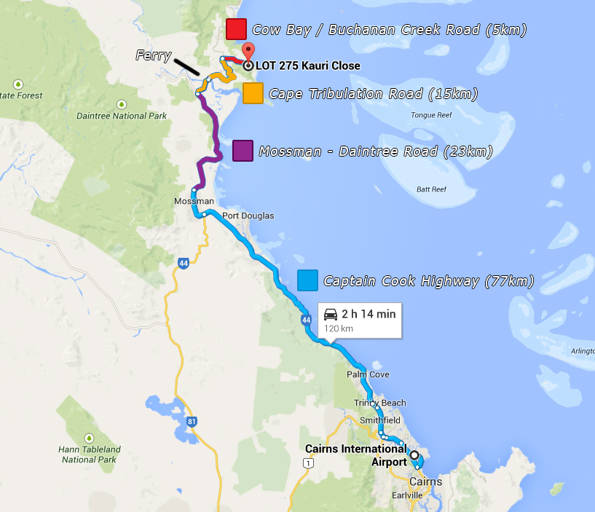

## Directions

First things first is to find your way on to ‘Captain Cook Highway’ and head north. If you are coming up from cairns airport, on ‘Airport Ave’ (the only way out) you’ll get to a set of lights, then turn right to get onto ‘Captain Cook Highway’. Keep following the main road and you’ll be on your way to Mossman.

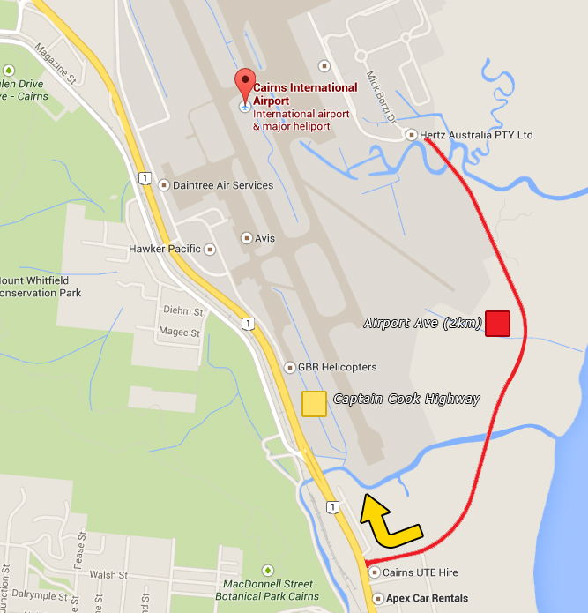

After about 70km you will then arrive at Mossman Town which is where Woolworths is located (Impossible to miss), this is where we recommend you to stop by and grab you groceries.

Then from Mossman Town, just keep following the main road and you will then soon be on ‘Mossman – Daintree Road’. After approximately 23 km turn off to your right on to ‘Cape Tribulation Road’. (Keep an eye out for the sign)

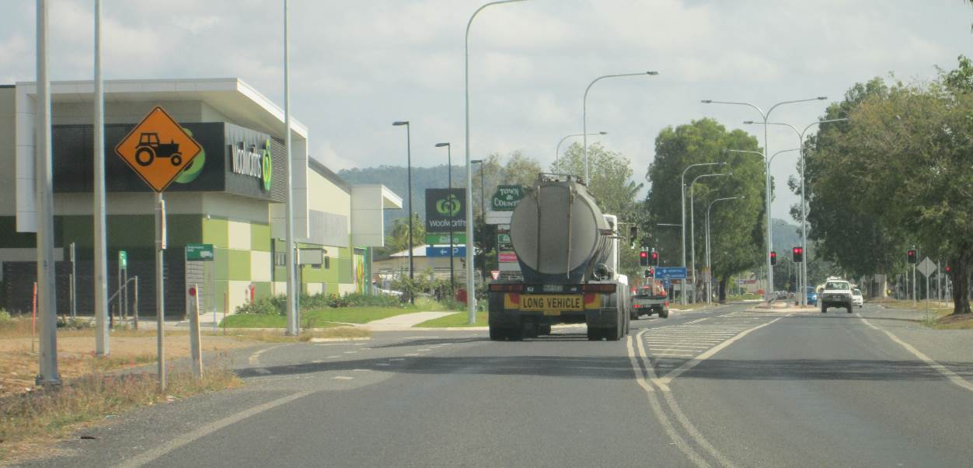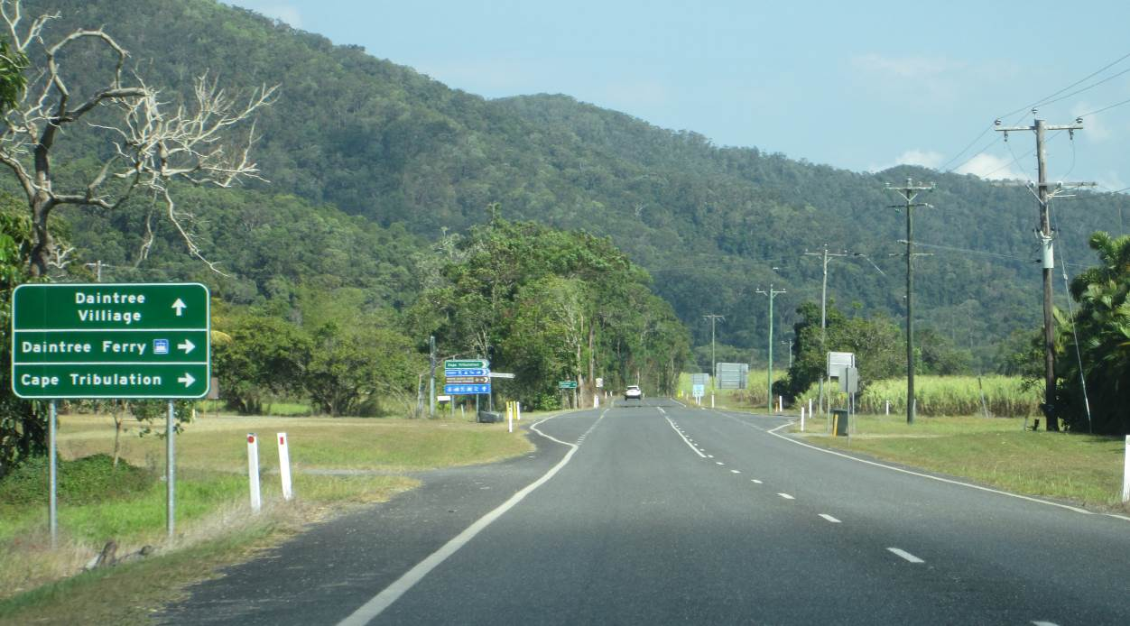

Once you’re on ‘Cape tribulation Road’ this will lead you to the ferry, the ferry includes a fee each time you use it and we do offer free ferry tickets at the house and we can also mail them to you for entrance as well.

Once you’re off the ferry you will still be on ‘Cape tribulation Road’, on your way you will see ‘Alexandra Rage Look Out’ this is where you can get phone signals with 3G and use the internet.

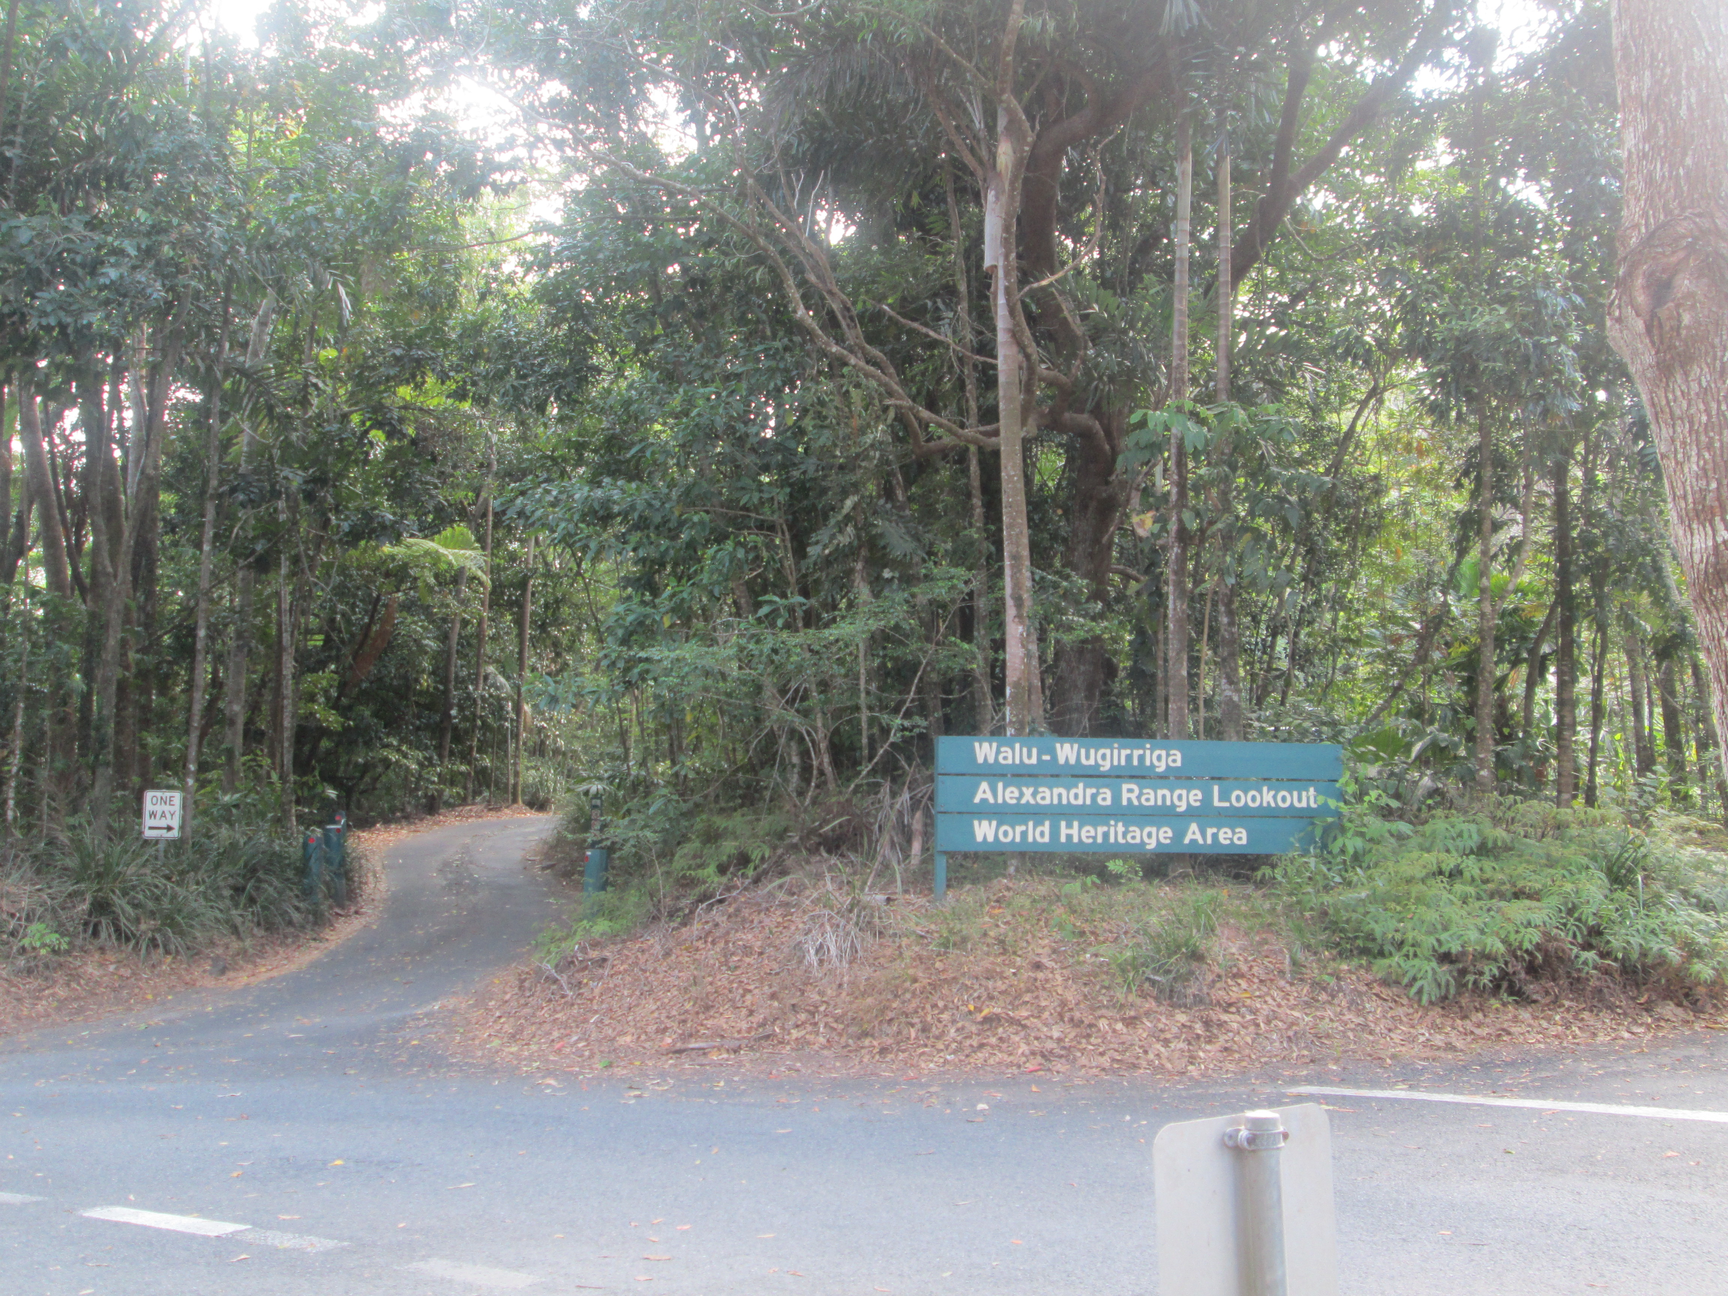

Continue to follow the main road until you see a turn off to the right with signs saying ‘Cow Bay’ and ‘Buchannan Creek Road’ (approximately 10 km away from the ferry)

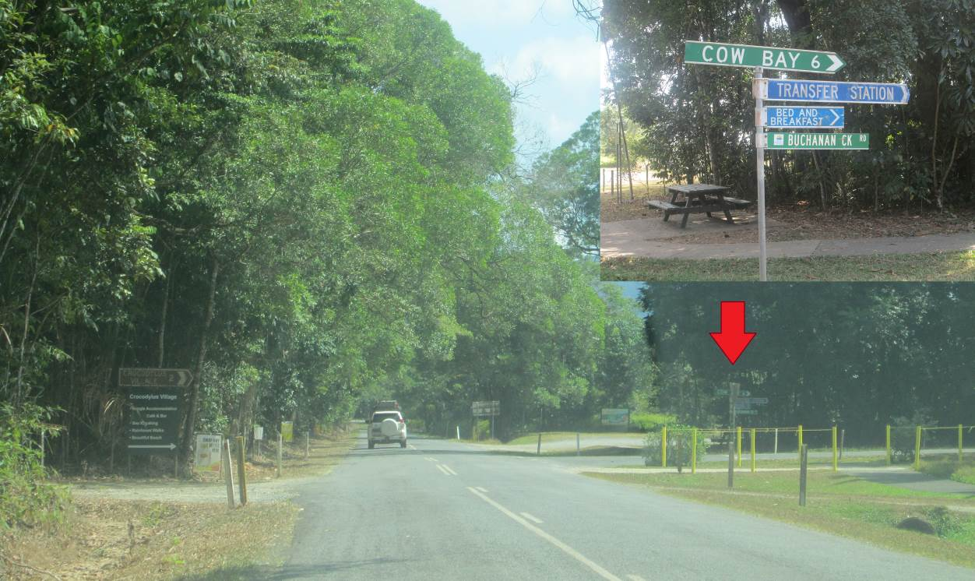

About 5 km down ‘Buchannan Creek Road’ there is a turn off on to ‘Silver Ash Road’ to your right.  
If you think you have gone pass it, don’t worry, just keep going until the end of the road which leads to Cow Bay beach, turn around and it’s the second turn off on your left.

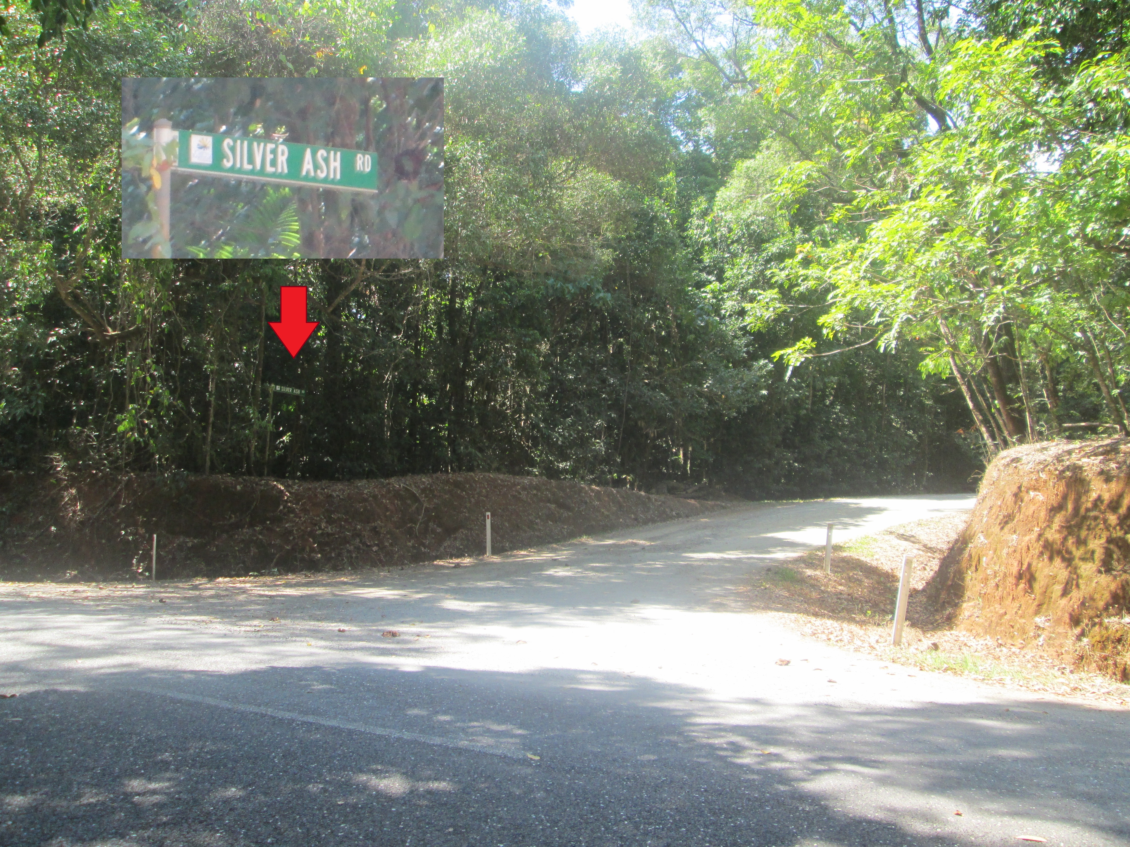

Once you’re on ‘Silver Ash Road’ turn to the left on to ‘Kauri Close’

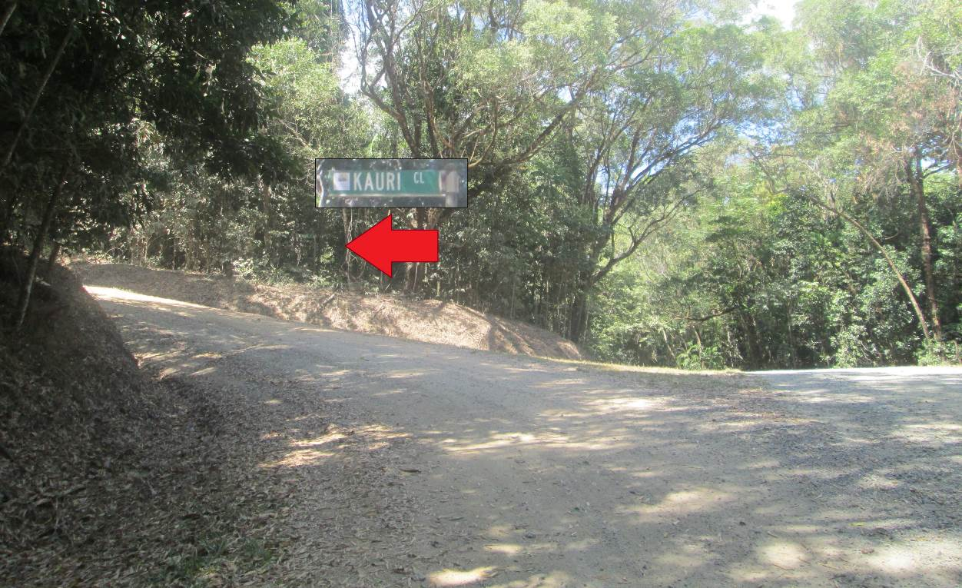

Follow up the road and on your left Look for house number 29 and/or ‘The Barn’ sign.

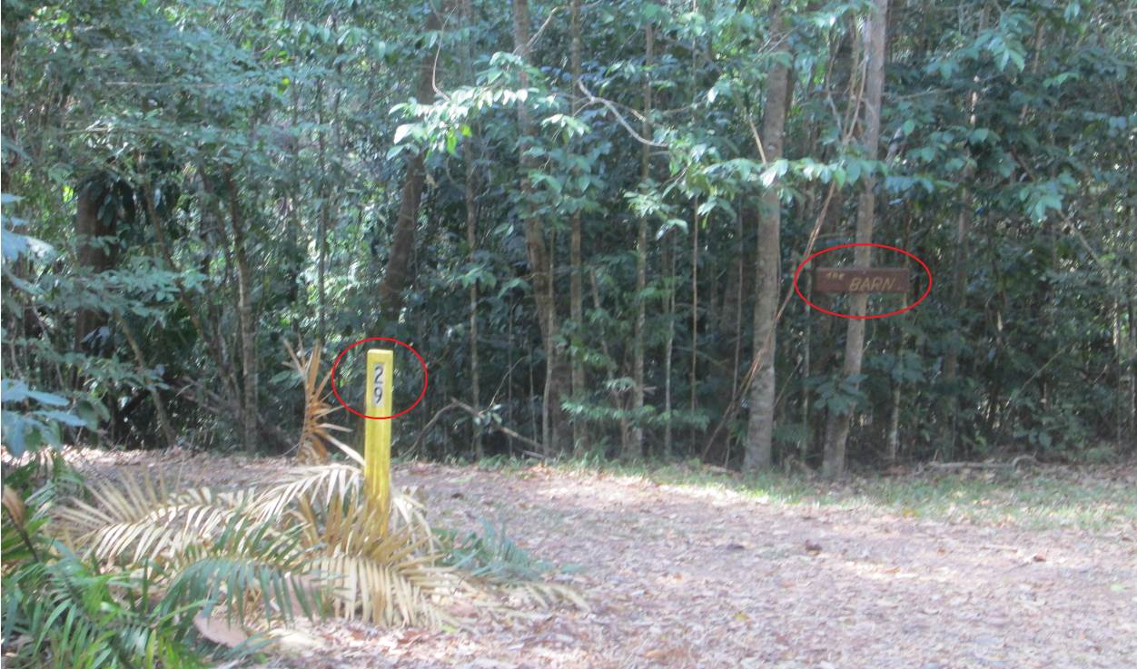

Turn in to the drive way to get to the house and you have reached your destination! ☺  
  
We hope you find this guide helpful and easy to follow, please let us know if you had any trouble finding the house or if you have any suggestion to help improve the guide, any feedback would be much appreciated.

## Contact Details

The Barn house number: (07) 4098 9184 (used to contact us on arrival day)

Mobile: 0459 499 192

Phone: (07) 40341266

Email: thebarn@thebarndaintree.com